**LAPORAN PRAKTIKUM PEMROGRAMAN 2**

Nama : Imam Sampurno Nugroho

NIM : 4511210002

Main.java

|  |
| --- |
| package com.p2.jdbc.latihan;  import java.sql.Connection;  import java.sql.DriverManager;  import java.sql.PreparedStatement;  import java.sql.SQLException;  import java.util.logging.Level;  import java.util.logging.Logger;  import java.math.BigDecimal;  public class Main {  public static void main (String [] args){  try{  //parameter yang dikirim adalah host, port, database, user, dan password  Connection conn=DriverManager.getConnection("jdbc:mysql://localhost:3306/p2","root","");  String query="INSERT INTO produk (nama,harga) VALUES(?,"+new BigDecimal(23000)+")";  PreparedStatement ps =conn.prepareStatement(query);  ps.setString(1,"lala");  ps.executeUpdate();  }catch(SQLException se){  Logger.getLogger(Main.class.getName()).log(Level.SEVERE,null,se);  }  }  } |

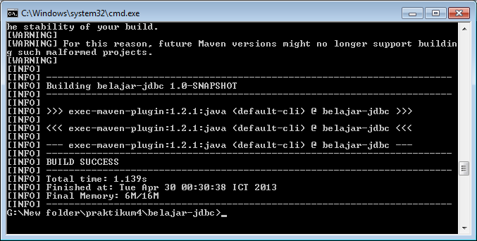

Update.java

|  |
| --- |
| package com.p2.jdbc.latihan;  import java.sql.*;  import javax.swing.*;  import java.util.logging.Level;  import java.util.logging.Logger;  public class Update{  public static void main(String[]args){  try{  //parameter yang dikirim adalah host, port, database, user, dan password  Connection conn=DriverManager.getConnection("jdbc:mysql://localhost:3306/p2","root","");  Statement stm = conn.createStatement();    String query="UPDATE produk SET nama='dipsi', harga='4500' WHERE id=1";  int hasil =stm.executeUpdate(query);    if(hasil==1){  JOptionPane.showMessageDialog(null,"berhasil Update");  }else{  JOptionPane.showMessageDialog(null,"gagal Update");  }  }catch (SQLException se){  Logger.getLogger(Update.class.getName()).log(Level.SEVERE,null,se);  }  }  } |

